בס"ד

**מטלה בתקשורת ומחשוב – מטלה 1:**

**Intro:**

1. **List 3 different protocols that appear in the protocol column in the unfiltered packet-listing window in step 7 above.**



The 3 different protocols that appear in the protocol column in the unfiltered packet listing in step 7 above are – TLSV1.2 , TCP and ARP.

1. **How long did it take from when the HTTP GET message was sent until the HTTP OK reply was received? (By default, the value of the Time column in the packetlisting window is the amount of time, in seconds, since Wireshark tracing began. To display the Time field in time-of-day format, select the Wireshark View pull down menu, then select Time Display Format, then select Time-of-day.)**



It take from when the HTTP GET message was sent until the HTTP OK reply was received 0.093872 seconds.

1. **What is the Internet address of the gaia.cs.umass.edu (also known as wwwnet.cs.umass.edu)? What is the Internet address of your computer?**



The Internet address of the gaia.cs.umass.edu is 128.119.245.12

The Internet address of my computer is 192.168.1.23

  
The Internet address of the gaia.cs.umass.edu is 192.168.1.23

The Internet address of my computer is 128.119.245.12

1. **Print the two HTTP messages (GET and OK) referred to in question 2 above. To do so, select Print from the Wireshark File command menu, and select the “Selected Packet Only” and “Print as displayed” radial buttons, and then click OK.**

**GET:**

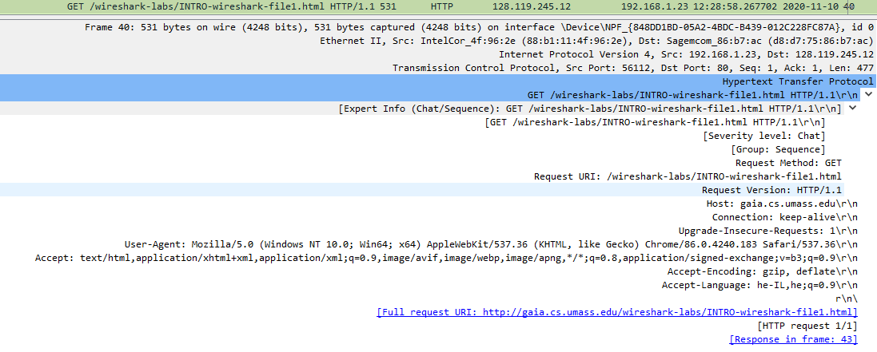

**OK:**

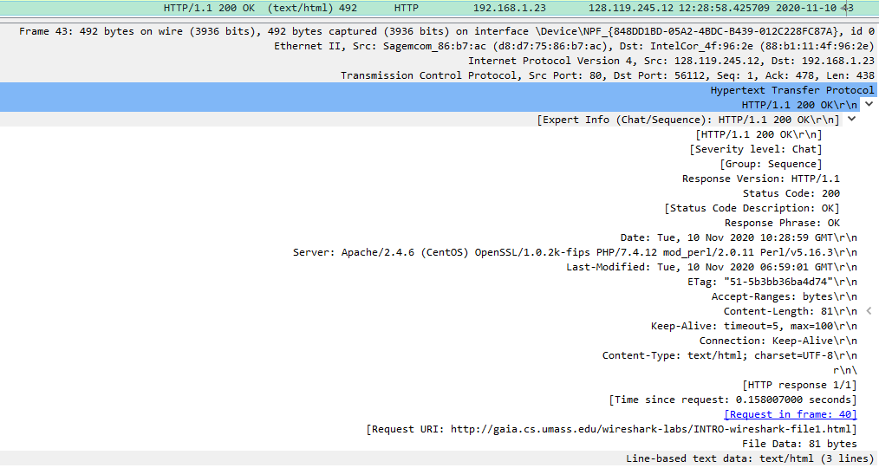

**Http:**

**1. The Basic HTTP GET/response interaction**

1. **Is your browser running HTTP version 1.0 or 1.1? What version of HTTP is the server running?**

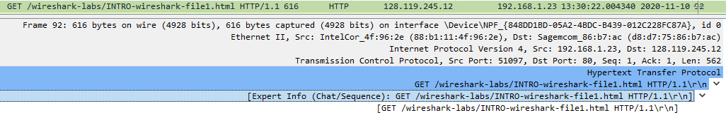

My browser is running HTTP version 1.1, also the server running.

1. **What languages (if any) does your browser indicate that it can accept to the server?**

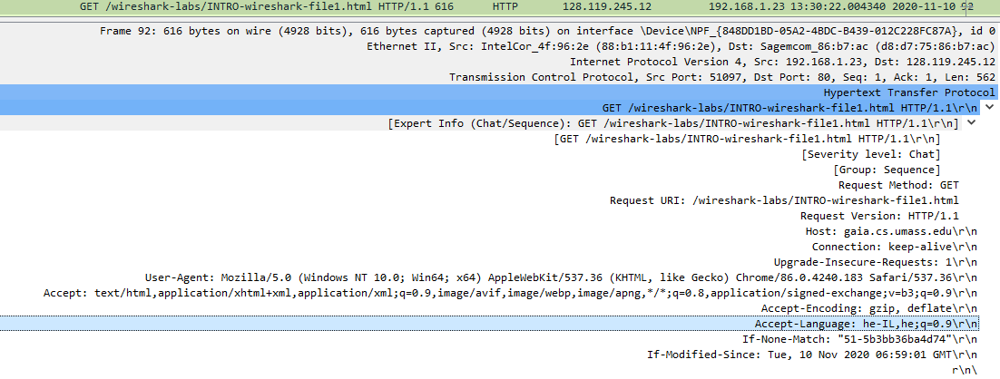

My browser indicate that it can accept Hebrew IL and Hebrew from the server.

1. **What is the IP address of your computer? Of the gaia.cs.umass.edu server?**



The IP of my address computer is 192.168.1.23

The IP of the server is 128.119.245.12

4) **What is the status code returned from the server to your browser?**

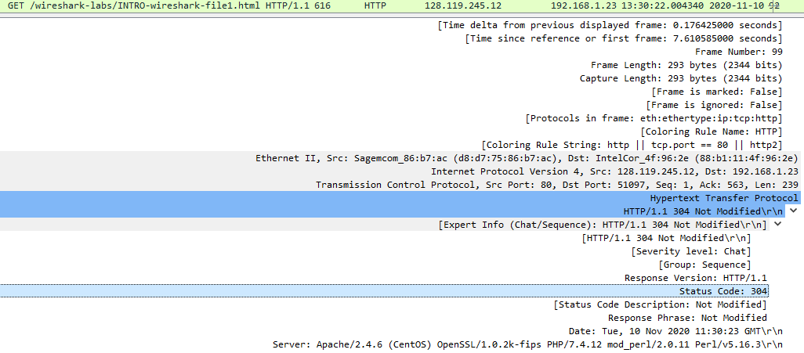

The status code returned from the server to my browser is 304.

1. **When was the HTML file that you are retrieving last modified at the server?**



The last modified file was on Tuersday, November 10, 2020 at 11:30:23 GMT.

1. **How many bytes of content are being returned to your browser?**

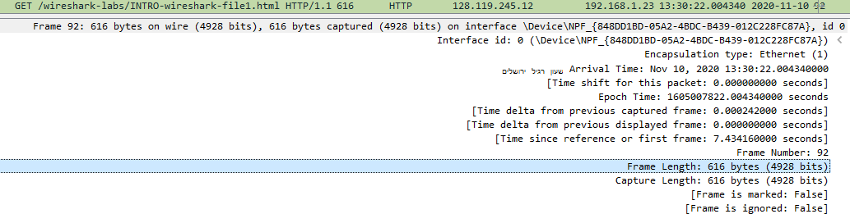

616 bytes of content are being returned of my browser.

1. **By inspecting the raw data in the packet content window, do you see any headers within the data that are not displayed in the packet-listing window? If so, name one.**

No, I don’t see.

1. **Inspect the contents of the first HTTP GET request from your browser to the server. Do you see an “IF-MODIFIED-SINCE” line in the HTTP GET?**

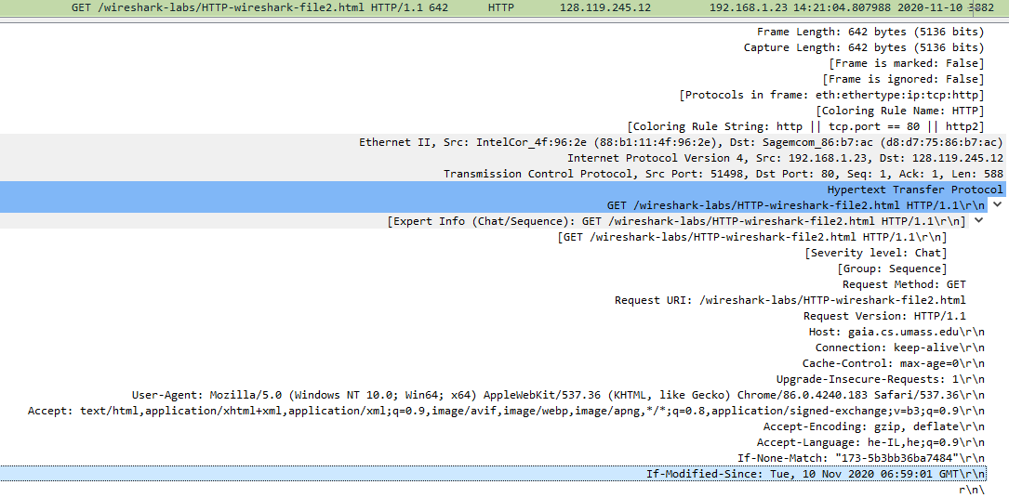

yes, Tuersday , 10 Nov 2020 06:59:01 GMT

**2. The HTTP CONDITIONAL GET/response interaction**

1. **Inspect the contents of the server response. Did the server explicitly return the contents of the file? How can you tell?**

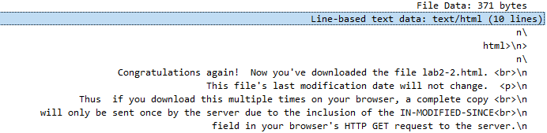

The server did explicitly return the contents of the file, we can sees it in “Line-based text data” that shows what the server sent to my browser

1. **Now inspect the contents of the second HTTP GET request from your browser to the server. Do you see an “IF-MODIFIED-SINCE:” line in the HTTP GET? If so, what information follows the “IF-MODIFIED-SINCE:” header?**

No, I don’t see.

1. **What is the HTTP status code and phrase returned from the server in response to this second HTTP GET? Did the server explicitly return the contents of the file? Explain.**

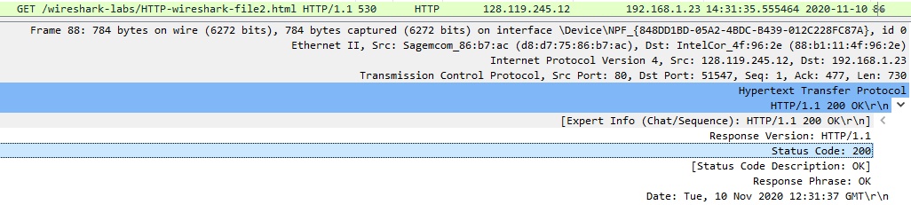

The HTTP status code is 200 OK.

**3. Retrieving Long Documents**

1. **How many HTTP GET request messages did your browser send? Which packet number in the trace contains the GET message for the Bill or Rights?**



My browser sent just one HTTP GET request to the server.  
The packet number in the trace contains the GET message for the Bill or Rights is 86.

1. **Which packet number in the trace contains the status code and phrase associated with the response to the HTTP GET request?**



The packet number in the trace contains the status code and phrase associated with the response to the HTTP GET request is 88.

1. **What is the status code and phrase in the response?**

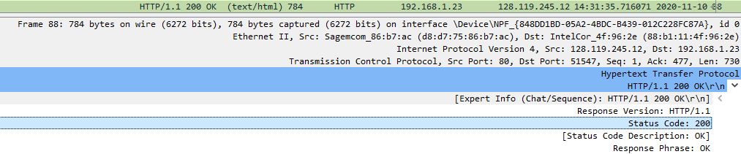

the code and pharse in the response was 200 OK

1. **How many data-containing TCP segments were needed to carry the single HTTP response and the text of the Bill of Rights?**

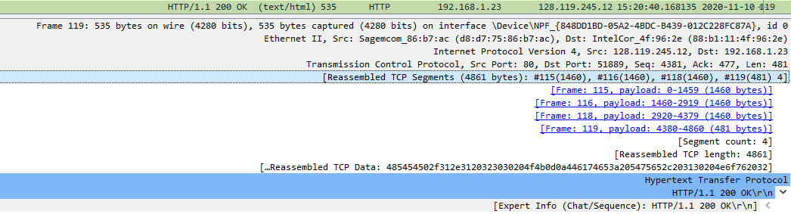

The data sent 4 TCP segments to the browser and then reassembled

**4. HTML Documents with Embedded Objects**

1. **How many HTTP GET request messages did your browser send? To which Internet addresses were these GET requests sent?**

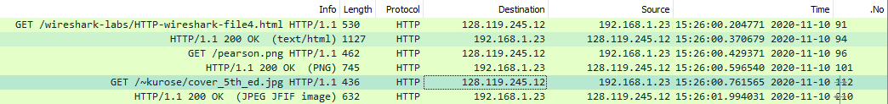

My browser sent three HTTP GET messages:

1)The initial page: 128.119.245.12

2)The pearson: 128.119.245.12

3)The cover: 128.119.245.12

1. **Can you tell whether your browser downloaded the two images serially, or whether they were downloaded from the two web sites in parallel? Explain.**

My browser downloaded the two images serially.

I assume the first image was sent and then the second image was sent, so apriority queue is created.

**5. HTTP Authentication**

1. **What is the server’s response (status code and phrase) in response to the initial HTTP GET message from your browser?**

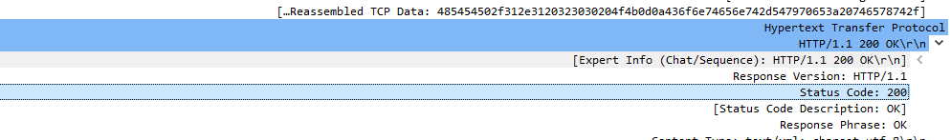

the server’s response (status code and phrase) in response to the initial HTTP GET message from your browse, HTTP version 1.1 and the response was 200 OK.

1. **When your browser’s sends the HTTP GET message for the second time, what new field is included in the HTTP GET message?**

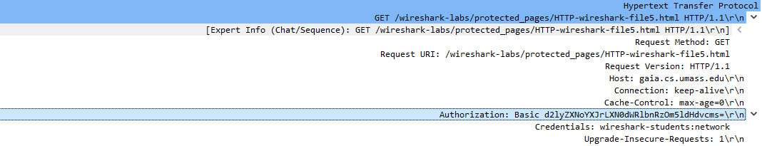

The new field that included now in the HTTP GET is the authorization field.